Diagonal.h

Cactus.cpp

SeqInFile.hpp

Vasarlas.hpp + main.cpp

mintaZH.hpp + main.cpp

Product.hpp

Department.hpp

Store.hpp

Costumer.hpp

main.cpp

Plants.hpp

Plants.cpp

Parcel.hpp

Garden.hpp

Gardner.hpp

main.cpp

Animal.hpp

Trophy.hpp

Hunter.hpp

Hunter.cpp

main.cpp

SolarSystem.hpp

SolarSystem.cpp

Planet.hpp

Planet.cpp

Starship.hpp

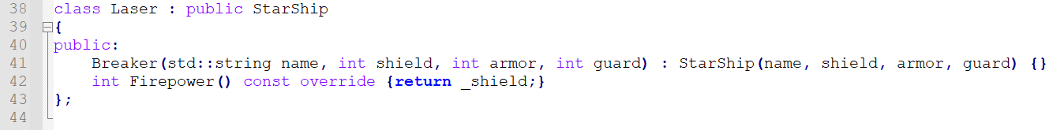

main.cpp

Signal.hpp

Magnetron.hpp

Magnetron.cpp

Lamp.hpp

Lamp.cpp

Door.hpp

Door.cpp

Button.hpp

Button.cpp

Microwave.hpp

Vaccine.hpp

Vaccination.hpp

Patient.hpp

Hospital.hpp

main.cpp

Ground.hpp

Ground.cpp

Creature.hpp

Creature.cpp

beadandó.cpp

